Year 2

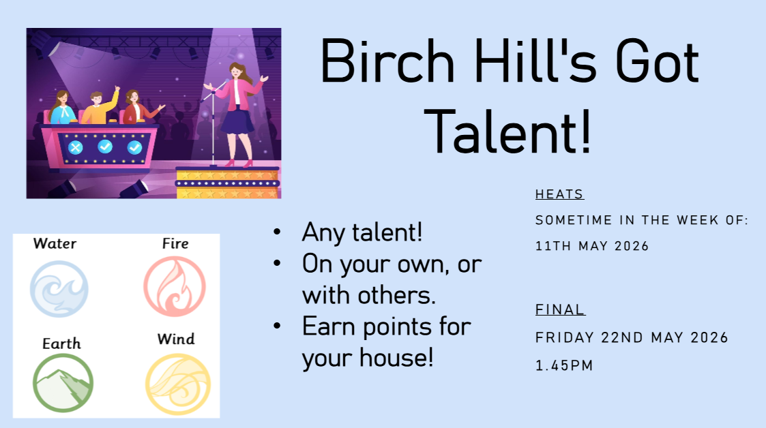
We will be holding auditions for Year 2 for Birch Hill’s got talent on Friday 15th May.
So, if you have a talent you want to share you can start rehearsing at home and show us on Friday 15th. If you do it with someone else, they must be in the same house as you as this is a house competition.
Please understand that we are only allowed to choose 2 acts to go through to the final on 22nd May.

