Year 1 Staffing Update

Dear Parent/Carer,

We would like to send our congratulations to Miss Karrie Browne and her partner who are expecting their first child. While this is exciting news for them, Miss Browne has decided to leave us at Easter. We all thank her for her hard work and wish her all the best for the future.

I am pleased to say that Mrs. Victora Perrin will be joining the Year 1 team after Easter. We are in the process of recruiting another teacher and once I have confirmation, I will let parents know the arrangements.

Yours sincerely,
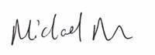
Michael Dillon
Headteacher

