Activity Ideas 2

Make the most of your unexpected time together! Let YOUR inner child out!
LAUGH LOVE LIVE
Keep a balance and be realistic about what you can do – working from home, school work etc will need to be factored in and it is also ok for children to have time when they entertain themselves.
Avoid competitive games and flash points
You might find it helpful to have a timetable
Try to keep the rules and boundaries that you already have in your home
Don’t worry about the housework!

- Start to collect items for a time capsule – what would you like to share with future generations
- make use of the sun shine and make shadow drawings – place items on paper in the sun and draw around the shadow they make
- ‘Shoe jumble’ – gather lots of pairs of shoes in a box or basket and see how long it takes to match the pairs -or hide one of each pair around the house or garden, each person takes a turn to search for their other shoe
- Treasure hunts – this takes a bit of planning. Decide on the starting point and this is where you place the first clue – then place second clue , 3rd etc depending on the age of the children and space. Examples of clues: go to the place where you wash your face! Here they find the next clue and so on – you’ll need to have put the treasure in place at the final point before you start.
Let the children set up a treasure hunt for you – they might want to draw a treasure map
- Learn 5 words a day in another language /British sign language or Makaton
- Create mnemonics
- make a hand in hand – each person draws around and cuts out/ decorates their hand – you then place one on top of the other - biggest to smallest and attach with glue or tape – put the hand in hand somewhere you can all see it and if children need a gentle check in, they can touch the hand ‘hand in hand ‘ this is something that you can include grand parents in too if they are able to post you a hand they have decorated (or not).
- Have a colour themed day – for example = a Harry Potter Day /Disney Day/Topsy Turvy Day/ Jungle Day/wacky hair day etc
- Set up a barbers shop/hair dressers or beauty salon (no scissors obvs!) use brushes clips hair bands etc and all get involved and connect
- I took this photograph this week – you could use it as a story discussions starter?
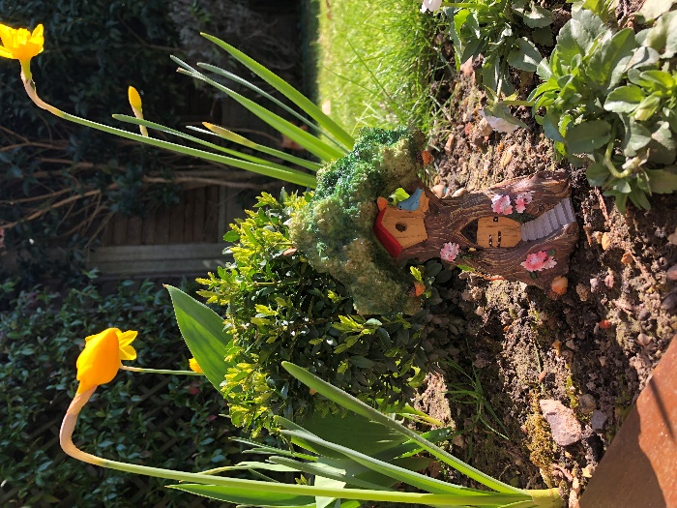

At the end of each day, share some thoughts about what you would like to do together in the future - write these hopes and aspirations down (one a day) and put them somewhere safe – in a jar or box.
I hope that you find this list helpful! Most of what I have included here can be shared using the phone, skype, whatsapp or video call with Grandparents and other people your children won’t be able to see at this time.

Take care, I am thinking of you all !

Very best wishes Heidi x

